**CYCLE 5**

Given dataset contains 200 records and five columns, two of which describe the customer’s annual income and spending score. The latter is a value from 0 to 100. The higher the number, the more this customer has spent with the company in the past:

Functions to familiarize:

* The purpose of Kmeans.fit() is to train the model with data.
* The purpose of Kmeans.predict() is to apply a trained model to data

==================================================

Q. Using k means clustering create 6 clusters of customers based on their spending pattern.

* Visualize the same in a scatter plot with each cluster in a different color scheme.
* Display the cluster labels of each point.(print cluster indexes)
* Display the cluster centers.
* Use different values of K and visualize the same using scatter plot

from sklearn.cluster import KMeans

from sklearn.datasets import make_blobs

import numpy as np

import matplotlib.pyplot as plt

import seaborn as sns

sns.set()

%matplotlib inline

import pandas as pd

customers = pd.read_csv('customer_data.csv')

customers.head()

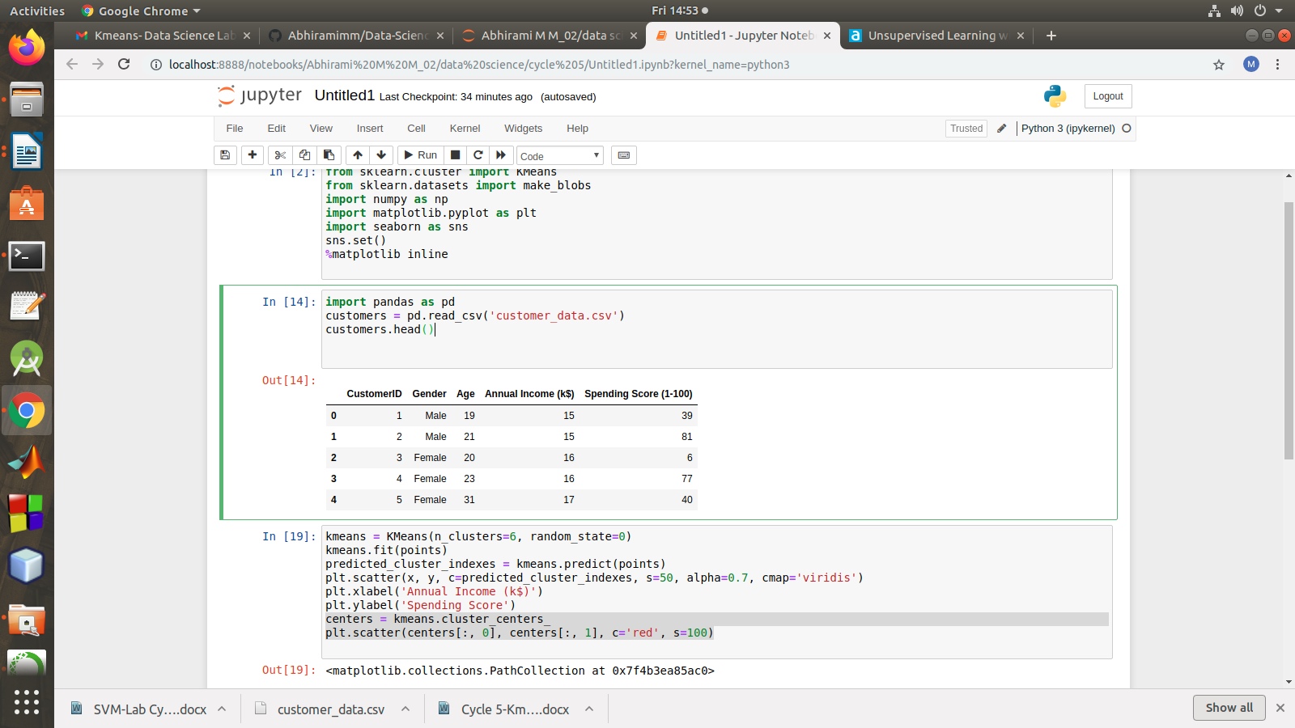

points = customers.iloc[:, 3:5].values

x = points[:, 0]

y = points[:, 1]

plt.scatter(x, y, s=50, alpha=0.7)

plt.xlabel('Annual Income (k$)')

plt.ylabel('Spending Score')

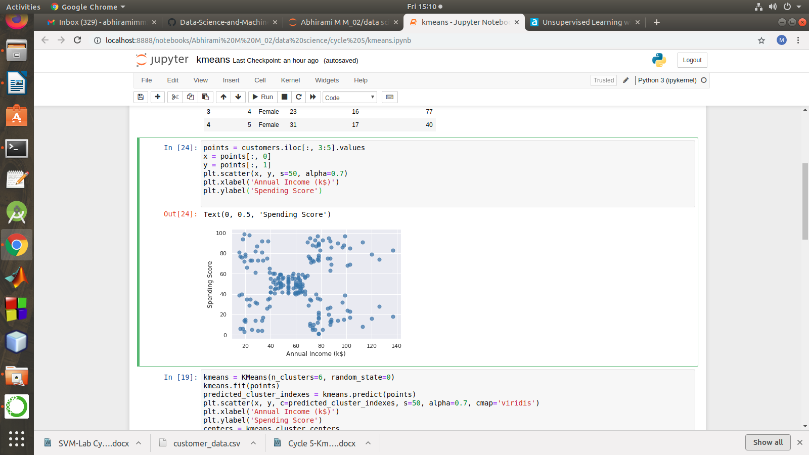

kmeans = KMeans(n_clusters=6, random_state=0)

kmeans.fit(points)

predicted_cluster_indexes = kmeans.predict(points)

print(predicted_cluster_indexes)

plt.scatter(x, y, c=predicted_cluster_indexes, s=50, alpha=0.7, cmap='viridis')

plt.xlabel('Annual Income (k$)')

plt.ylabel('Spending Score')

centers = kmeans.cluster_centers_

plt.scatter(centers[:, 0], centers[:, 1], c='red', s=100)

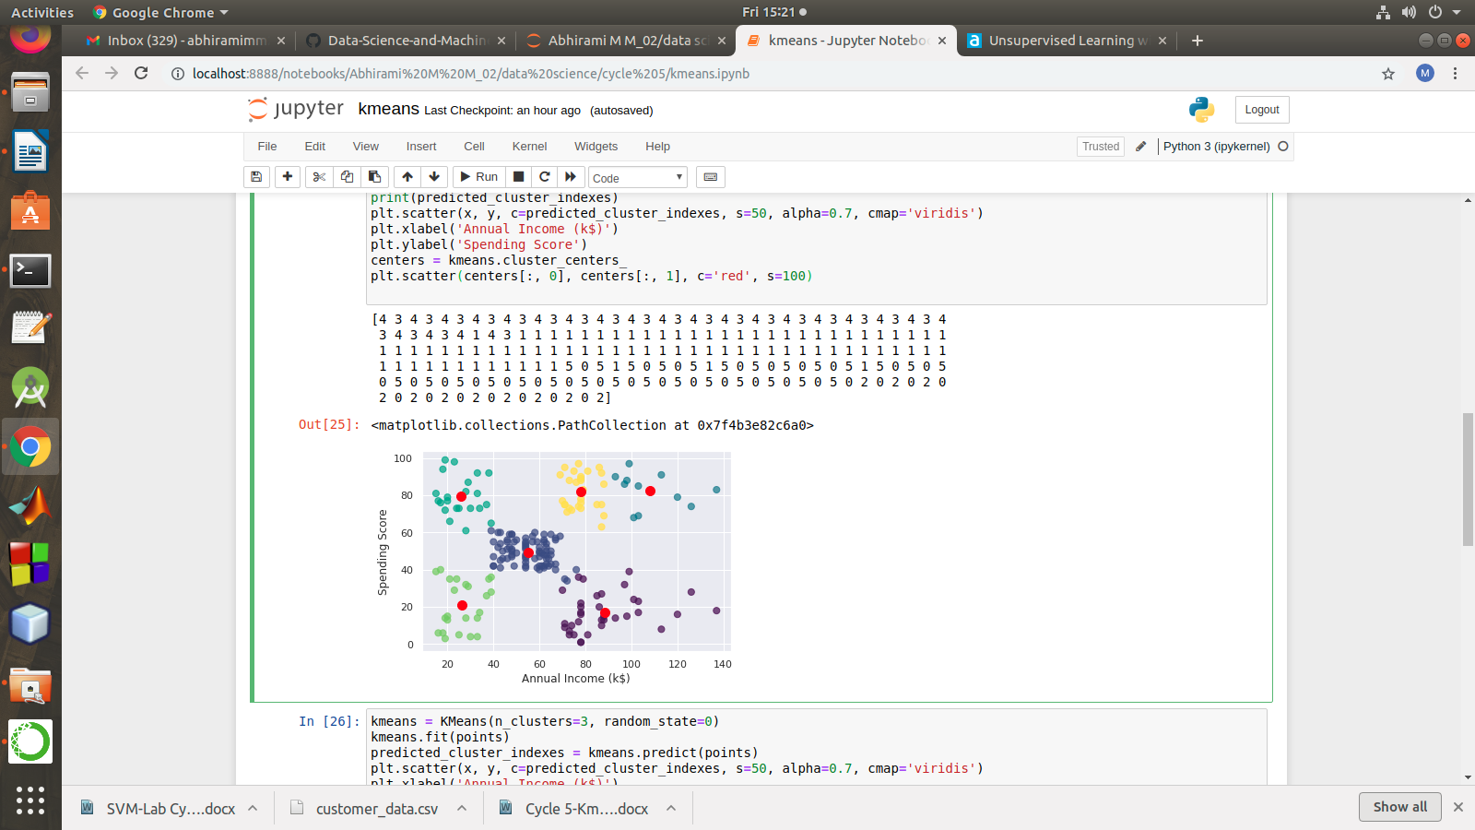

kmeans = KMeans(n_clusters=8, random_state=0)

kmeans.fit(points)

predicted_cluster_indexes = kmeans.predict(points)

plt.scatter(x, y, c=predicted_cluster_indexes, s=50, alpha=0.7, cmap='viridis')

plt.xlabel('Annual Income (k$)')

plt.ylabel('Spending Score')

centers = kmeans.cluster_centers_

plt.scatter(centers[:, 0], centers[:, 1], c='red', s=100)

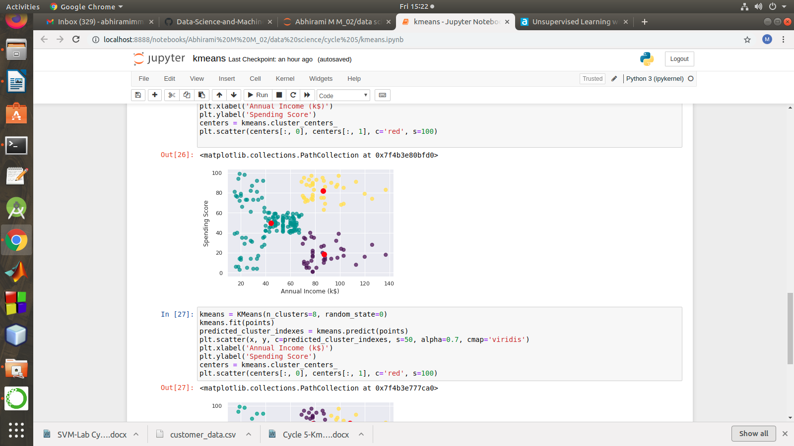

kmeans = KMeans(n_clusters=8, random_state=0)

kmeans.fit(points)

predicted_cluster_indexes = kmeans.predict(points)

plt.scatter(x, y, c=predicted_cluster_indexes, s=50, alpha=0.7, cmap='viridis')

plt.xlabel('Annual Income (k$)')

plt.ylabel('Spending Score')

centers = kmeans.cluster_centers_

plt.scatter(centers[:, 0], centers[:, 1], c='red', s=100)

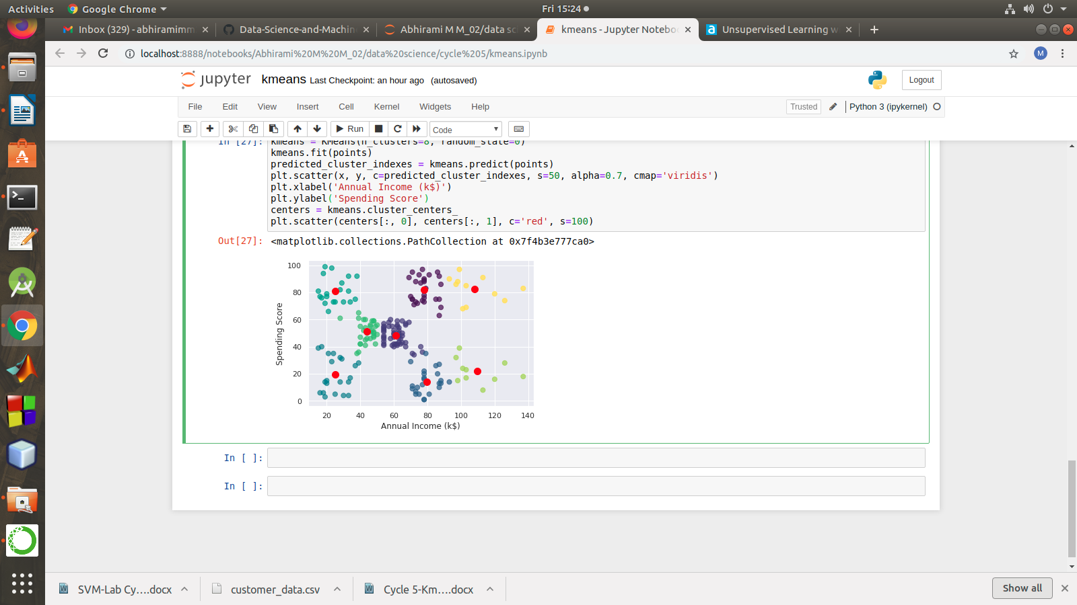

References:

<https://www.atmosera.com/blog/unsupervised-learning-with-k-means-clustering-part-ii/>

https://nickmccullum.com/python-machine-learning/k-means-clustering-python/